**WEBPACK**

# **What is Webpack?**

Webpack is a bundling tool for our code, it can many files and bundle it into a few files for faster loading of our website. And less HTTP request to fetch files.

**Webpack is a tool to minified our code.**

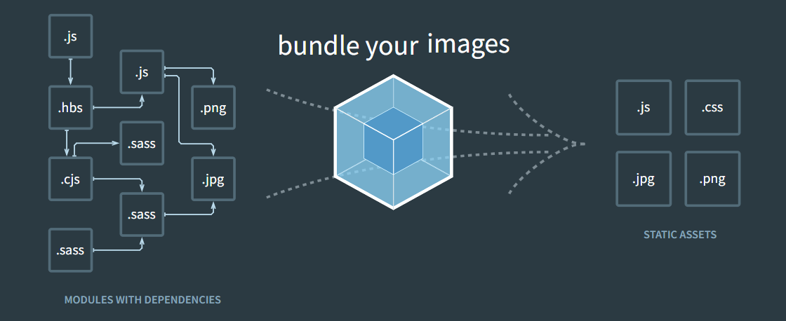

# **Installing Webpack in typescript project**

*npm I –save-dev webpack webpack-cli webpack-dev-server ts-loader typescript*

* **webpack:** used to bundle our files to produce minified code files.
* **webpack-cli:** allows us to run webpack commands in the cli.
* **webpack-dev-server:** used to spin up webpack native development server.
* **ts-loader:** helps webpack to compile the typescript files.
* **typescript:** to keep track of the typescript version our project is developed in.

# **Prerequisites to use webpack with typescript:**

* Remove all the .js extensions from your ES6 imports.
* Disable the **rootDir** property of the tsConfig.json, as it is taken care of by webpack.
* Create a **webpack.config.json** file for development and **webpack.config.prod.js**  file for production.
* Set the **target** to **ES5**(to support older browsers as well) and **ES6**(to support only modern browsers)
* If using the **webpack-dev-server** replace the file in your **index.html** by **bundle.js**  that you have specified in the webpack.config.js file.

# **Normal webpack.config.js file:**

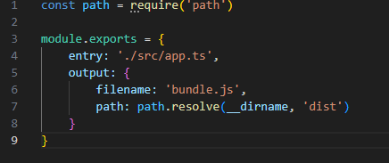

# **webpack.config.js file with typescript support: (development)**

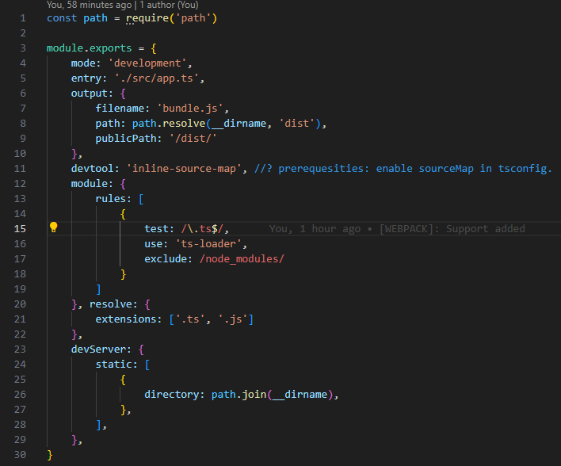

# **webpack.config.prod.js file with typescript support: (production)**

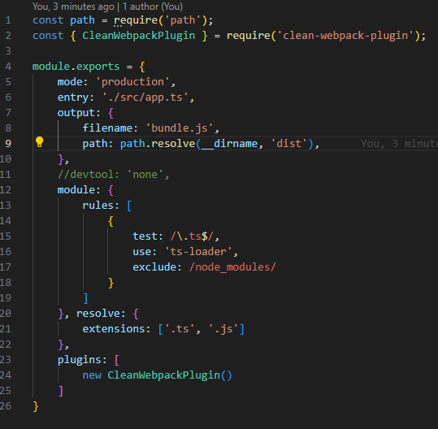

# **Using webpack native server(used by react behind the scenes):**

* set the **start** script in the package.json file to ‘**webpack-dev-server**’.



* run the server using **npm start.**
* It will generate the minified code or build behind the scenes in the memory, but do not write it on the disc.
* So similarly in react upon running **npm start** it will behind the scenes build the application and server us without write the build on the disk(making as visible in folder).

# **Using webpack to build the application:**

* Set the **build** property to ‘**webpack –config webpack.config.prod.js**’ to build our application.
* Setting the **–config** flag tells webpack to utilize the **webpack.config.prod.js**  file for building our application.
* Since we are utilizing the production config it will apply all optimization to the code and outputs as an minified **bundle.js** file as we specified in the webpack.config.prod.js